**JUnit Testing Exercises**

**Exercise 1: Setting Up JUnit Scenario:**

**CODE:**

pom.xml:

<dependency>

<groupId>junit</groupId>

<artifactId>junit</artifactId>

<version>4.13.2</version>

<scope>test</scope>

</dependency>

**Calculator.java**

**package** com.example;

**public** **class** Calculator {

**public** **int** add(**int** a, **int** b) {

**return** a + b;

}

**public** **int** subtract(**int** a, **int** b) {

**return** a - b;

}

}

**Calculatortest.java**

package com.example;

import static org.junit.Assert.*assertEquals*;

import org.junit.Test;

public class Calculatortest {

@Test

public void testAdd() {

Calculator calc = new Calculator();

int result = calc.add(5, 3);

*assertEquals*(8, result);

}

@Test

public void testSubtract() {

Calculator calc = new Calculator();

int result = calc.subtract(10, 4);

*assertEquals*(6, result);

}

}

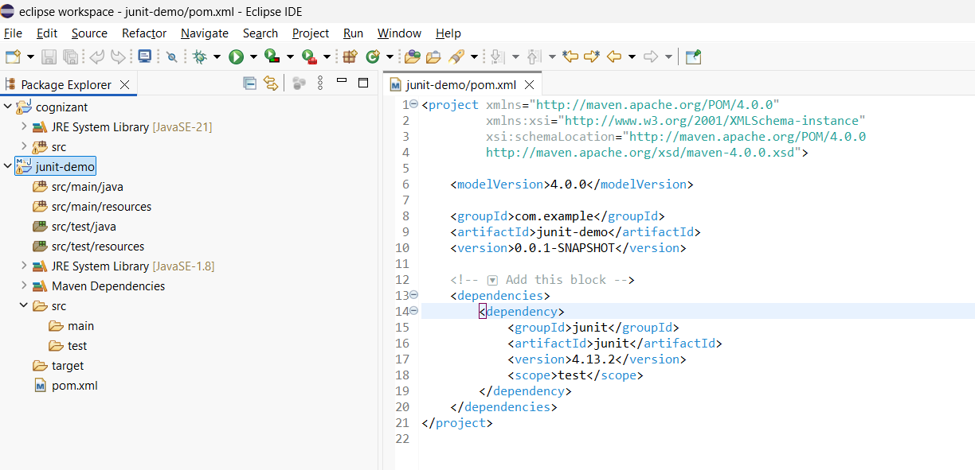

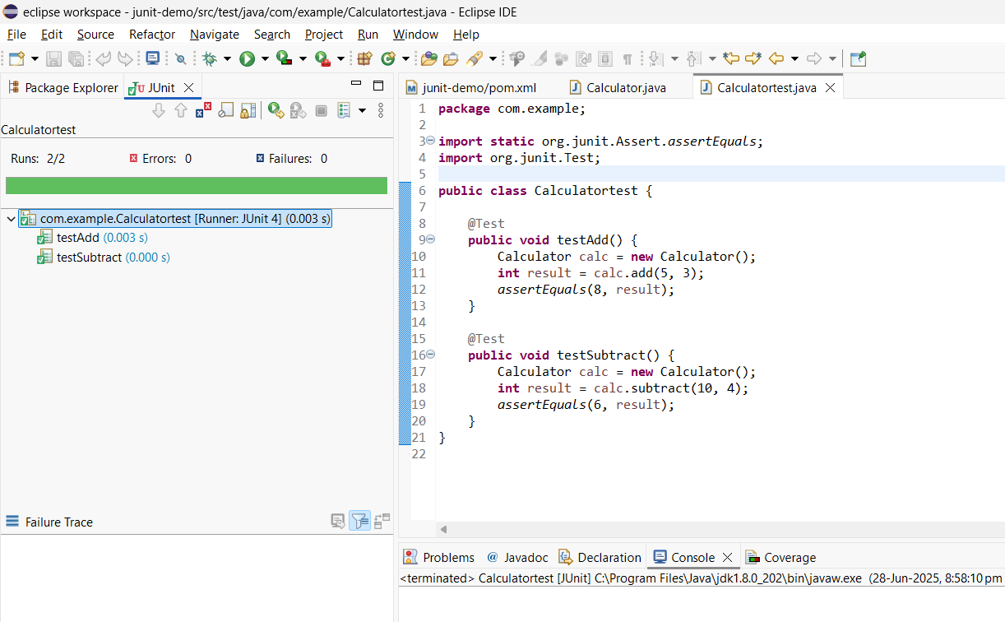

**Exercise 3: Assertions in Junit**

package com.example;

import static org.junit.Assert.*;

import org.junit.Test;

public class AssertionsTests {

@Test

public void testAssertions() {

// Assert equals

*assertEquals*(5, 2 + 3);

// Assert true

*assertTrue*(5 > 3);

// Assert false

*assertFalse*(5 < 3);

// Assert null

*assertNull*(null);

// Assert not null

*assertNotNull*(new Object());

}

}

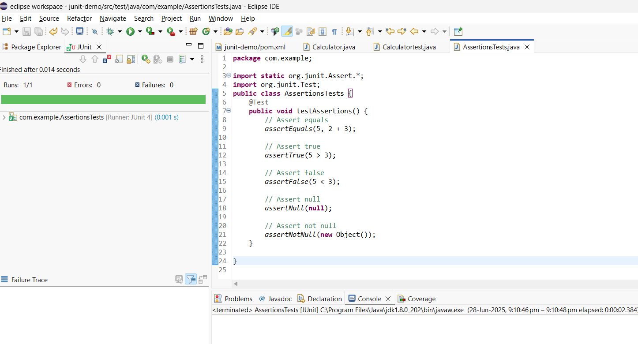

**Exercise 4: Arrange-Act-Assert (AAA) Pattern, Test Fixtures, Setup and Teardown Methods in Junit**

package com.example;

import static org.junit.Assert.*;

import org.junit.Before;

import org.junit.After;

import org.junit.Test;

public class CalculatorAAAtest {

private Calculator calculator;

@Before

public void setUp() {

calculator = new Calculator();

System.*out*.println("Setting up...");

}

@After

public void tearDown() {

System.*out*.println("Cleaning up...");

}

@Test

public void testAdd() {

int a = 10;

int b = 20;

int result = calculator.add(a, b);

*assertEquals*(30, result);

}

@Test

public void testSubtract() {

int a = 25;

int b = 5;

int result = calculator.subtract(a, b);

*assertEquals*(20, result);

}

}

